**PROJECT DESIGN PHASE 2**

**Technical Architecture**

|  |  |
| --- | --- |
| **Team ID** | PNT2022TMID49391 |
| **Project Name** | News Tracker Application |
| **Team** | Sivagamasundari S, MahalakshmiG,  Devika L, Dharshaniya V |

**News Tracker Application: -**

As our lives are very busy these days, we often feel we need more than 24 hrs. a day to cope up with everything we have in our schedule. Well, that's not possible but reducing the time by changing the conventional method of reading news can help. Just tell us what market news you're interested in and get a quick peek for the day. Only read what you feel is relevant and save your time. This app helps you to query for all information about Indices, Commodities, Currencies, Future Rates, Bonds etc. as on official websites. **Technical Architecture:**

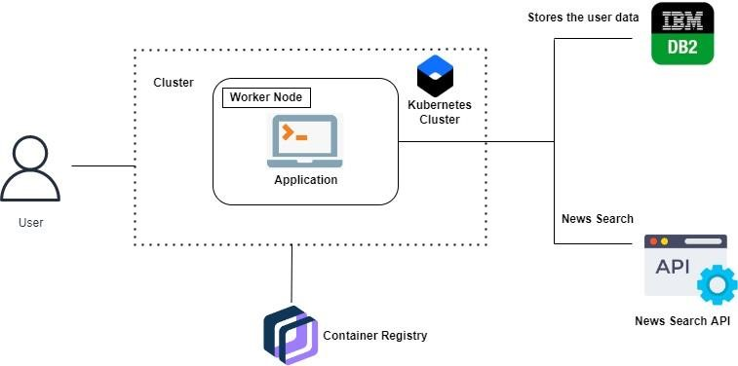

**Project Workflow: -**

* The user interacts with the application.
* Registers by giving the details.
* Integrate the application with news APIs and store the data in the database.
* The database will have all the details and the user can search the news by using a search bar.